Chapter 8, Solution 22.

Compare the characteristic equation with eq. (8.8), i.e.
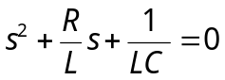
we obtain
